Thursday, January 08, 2026
TO: All Brown County Fair Board, 4-H, and County Commission
RE: Brown County Fair Board Meeting, January 14th @ 6:30 pm
Buildings & Grounds
Camping
Carnival & Vendors
Competitive Exhibits
Food & Catering
Friends of the Fair
Grandstand Entertainment
Junior Fair Board
Legacy
Livestock
Marketing
Rodeo
Special Events
Brown County Courthouse Basement Community Room

Please review the enclosed minutes of the past meeting.

Agenda:
Call to order and flag pledge.
Visitors –
Approval of previous meeting minutes
Opportunity for Public Comment
Treasurer’s report and approval of bills
Communications
Fair Foundation Report
Commission Report
4-H Youth Program Educator’s Report
Fair Office Reports
Committee Reports
Old Business:

New Business:
Gate Control – Aberdeen Curling Club, Trash-Cycling Club (B&G)
SUV Drivers – Groton Lions Club (Ent.)
Other Contracts

All other matters to come before the Board.
Executive Session

Nancy Radke
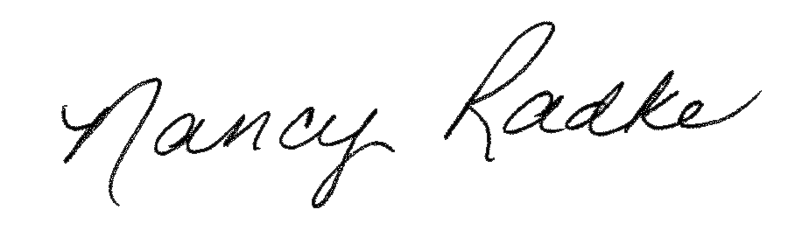
President
Notice: B&G/Vendors Committees 1/14/25 at 6 PM

